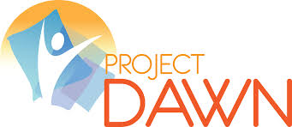

Project DAWN
Project DAWN (Deaths Avoided With Naloxone) is a community-based overdose education and naloxone distribution program that was created as a way to combat Ohio’s opioid overdose epidemic. Naloxone (also known as Narcan) is a medication that can reverse an overdose caused by an opioid drug (heroin or prescription pain medications). When administered during an overdose, Naloxone blocks the effects of opioids on the brain and quickly restores breathing.
It takes less than 30 minutes to obtain a kit that could save a life. Attendees learn to:
- Recognize the signs and symptoms of overdose
- Distinguish between different types of overdose
- Perform rescue breathing
- Call emergency medical services
- Administer intranasal Naloxone

The kit includes:
- 2 - 4mg doses of Narcan Nasal Spray
- 1 pair of nitrile gloves
- 1 face shield
- 1 educational DVD
- 1 educational booklet
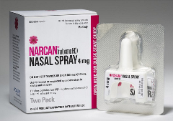

Obtaining a Project DAWN kit:

With the passage of HB 170, the kits may be dispensed to the individual with addiction, as well as a family member, friend, or loved one.
You may obtain a naloxone kit for free through the DAWN program. Walk-in's are accepted.
If you would like to schedule an appointment or would like more information, visit The Ohio Department of Health's Project DAWN Website
Project DAWN kits are free. Donations are accepted but not required.

